Work breakdown structure
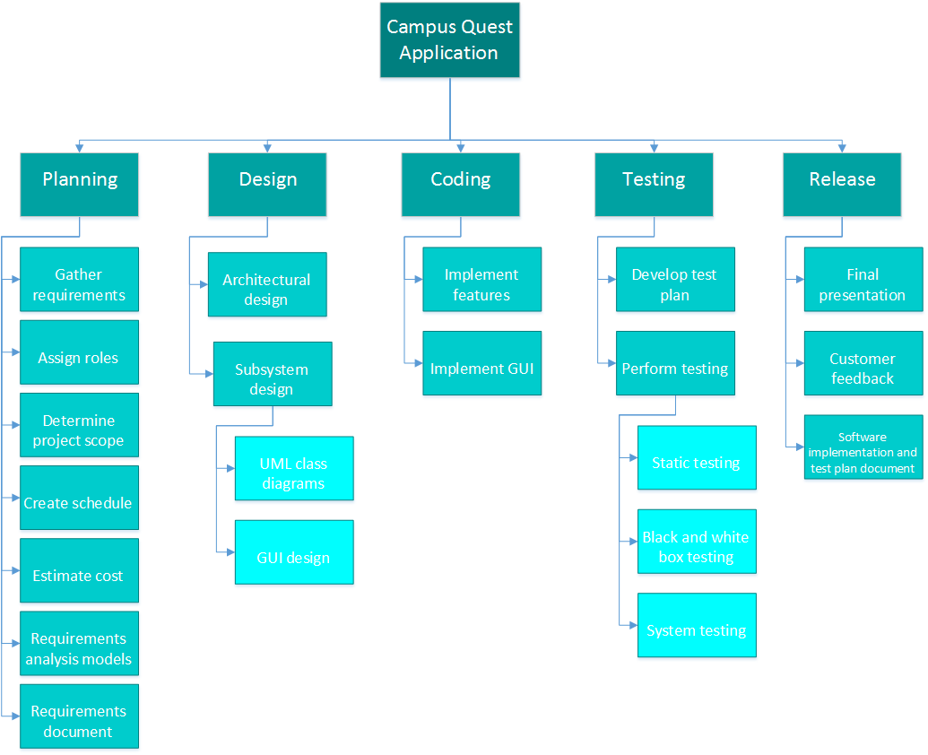

Resource requirements & estimation.
Name | Description | Price
Cost of labor | Sotware design, implementation and testing
Android Studio | IDE for Android application development | Free
Microsoft Project | Necessary for project management, organization and scheduling | $590.00
Microsoft Visio | Required to create use case , UML and other types of diagrams | $590.00
Inkscape | Graphics editor used to create illustrations and logos for GUI | Free
Android phones | 3 phones equired for testing | $1800.00
 | Total cost = $

We will require a total of $xxxx to develop Campus Quest application. We will need Mirosoft Project for project management, organization and scheduling. Microsoft Visio will be required to create various diagrams necessary for software development. Both applications cost $590.00 each. Android Studio is required to create code for the application. We will use open-source graphics editor Inkscape to create necessary graphics for the project. Both Android Studio and Inkscap are free. In addition, three andriod phones will be needed for testing purposes (one phone for each software developer).

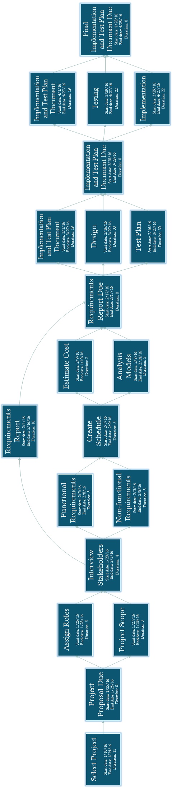
PERT CHART

Performance issues
Campus Quest will need internet connection in order to perform most of its tasks. Its speed and responsiveness will be limited by the speed of the local network or phone internet service provider. Campus Quest largely depends on Google Maps. Therefore, any Google maps performance issues will directly affect our application. Our application also uses Wave Transit Real-Time Bus Tracking web site to track buses and display bus routes. Unfortunately, not all the buses are equiped with GPS trackers, or at least not all of the trakers are functional. In addition, Wave Real-Time Bus Tracking is not always available. A lot of the information provided by Campus Quest cannot be updated automatically. For example, in case of a bike rack removal or installation, or location change of point of interest, that information will have to be manually updated. Therefore, it will not always be up-to-date.

Project monitoring and control mechanism.
We belive that communication and the ability to collaborate is the key to the success of the project. Team members will use email, text messaging, and instant messaging appliaction Slack to communicate with each other. Team members will also meet face-to-face once or twice a week. During these meetings, the project manager will make sure all team members know exactly what tasks they are responsible for, check the progress of the team to make sure the project is on schedule and take necessary actions if the project is behind the schedule. In addition, every team member will go over completed tasks, ask for feedback, and make changes if neccessary. This will keep everybody updated on every aspect of the project and help the project manager to make sure evrybody adheres to the schedule. Team members will use GitHub to ensure that every team member has the latest version of all documents and source code.

Risk plan
Risks | Category | Probability | Impact | RMMM
Losing team member | ST | 30% | 3 | Distribute the work load between other team members
Computers crash | TE | 20% | 4 | Use computers at the library
Project takes longer than expected | PS | 30% | 2 | Put in more hours until we catch up
Failure to implement one or more features due to unforeseen problems | TE | 15% | 2 | Create a new feature somewhat related to the uncompleted feature for substitution
Lack of technical skills (steep learning curve) | ST | 10% | 3 | Find an experienced person who can teach the whole team the necessary skills in a short period of time

Risk Categories: PS - Project size risk TE - Technology Risk ST – Staff Size and Experience Risk
Impact Values: 1 - Catastrophic 2 - Critical 3 - Marginal 4 - Negligible

